**Automation using Ansible**

In this project,we use the ansible host (controller) server to automate the client server.

We start by creating two instances one acts as a master and other as slave.

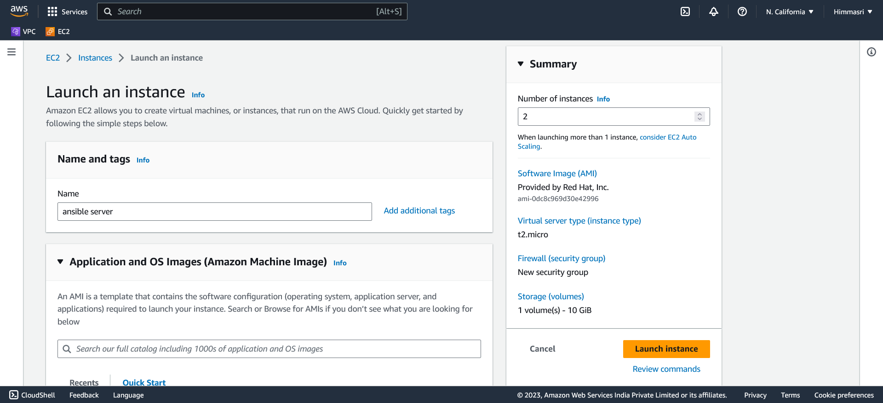

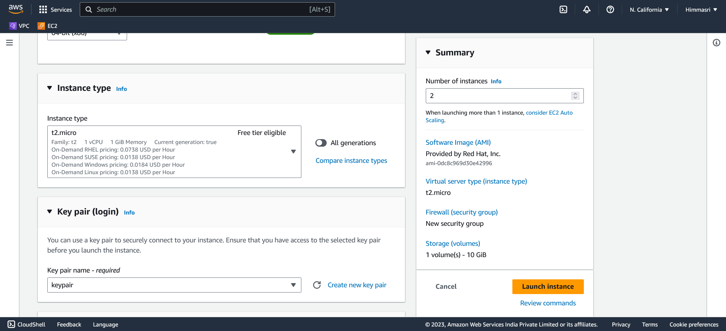

Start by giving the name to the instance.

Choose the application machine image(AMI) ie the type of operating sytem to run on EC2.

We are using Redhat AMI.

Select the instance type and keypair that is available in local system.

Specify the Networking and security group rules.

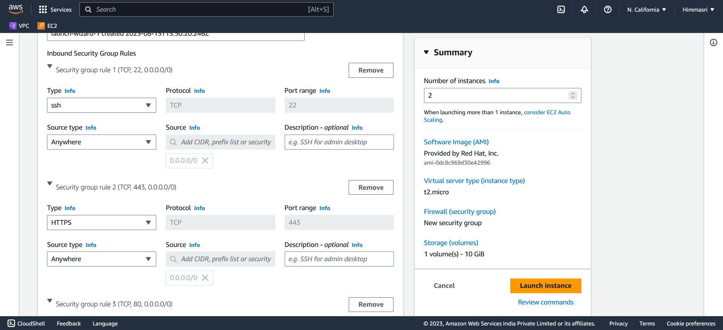

Once the instances are created we can use connect them using ssh or IP address.

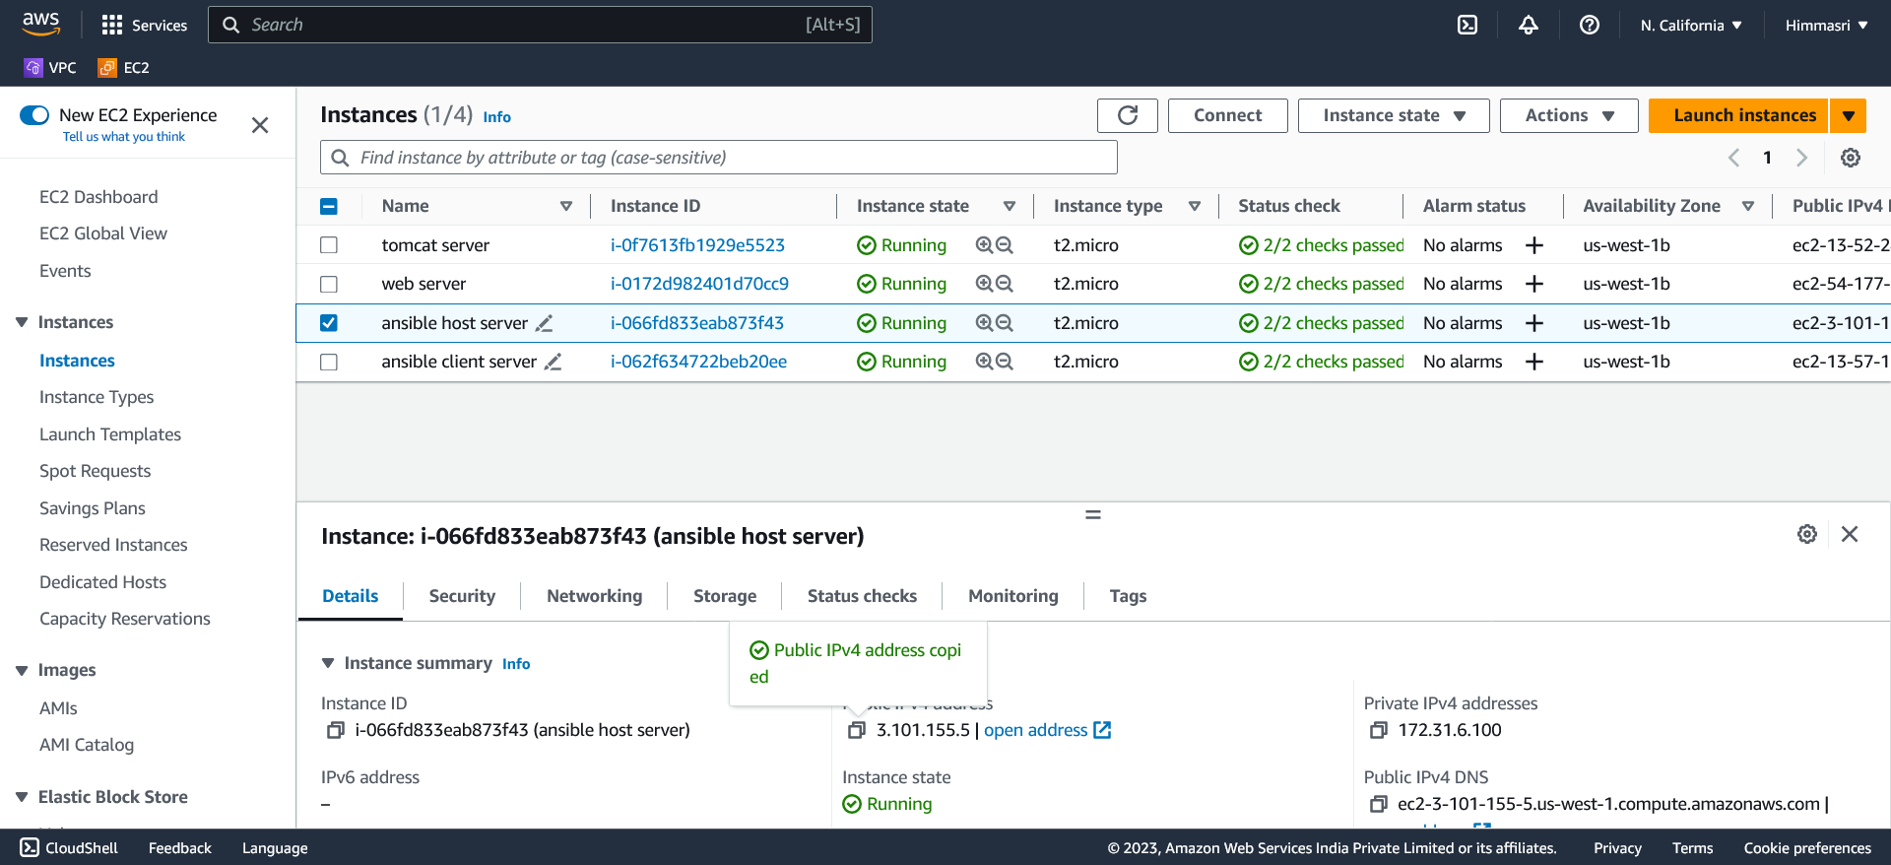

Here I’m using Mobaxterm to connect the EC2 instance.

Using sudo su- to get the root privileges and yum update.

We need to update in both the host server and client server.

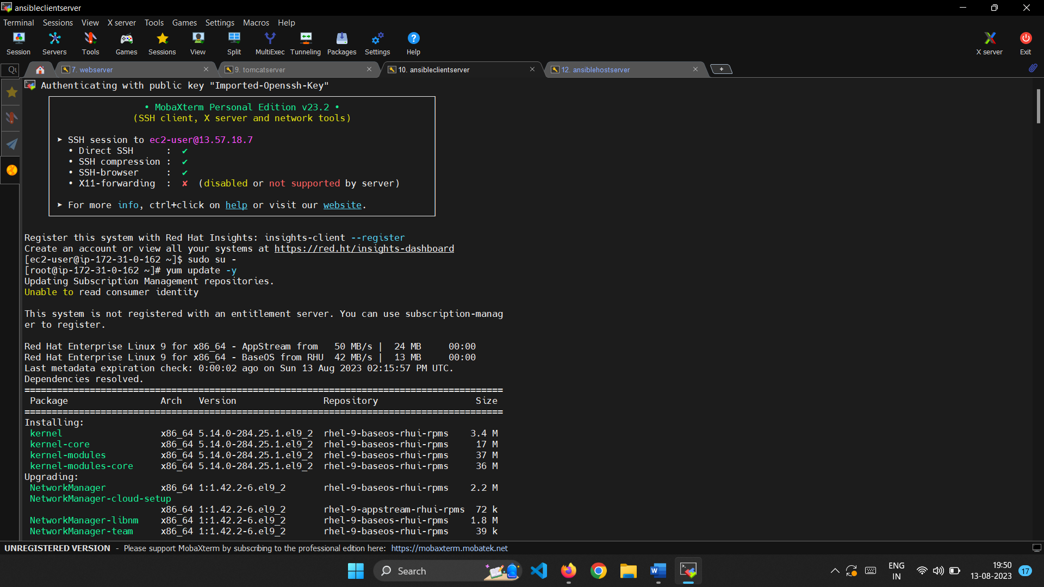

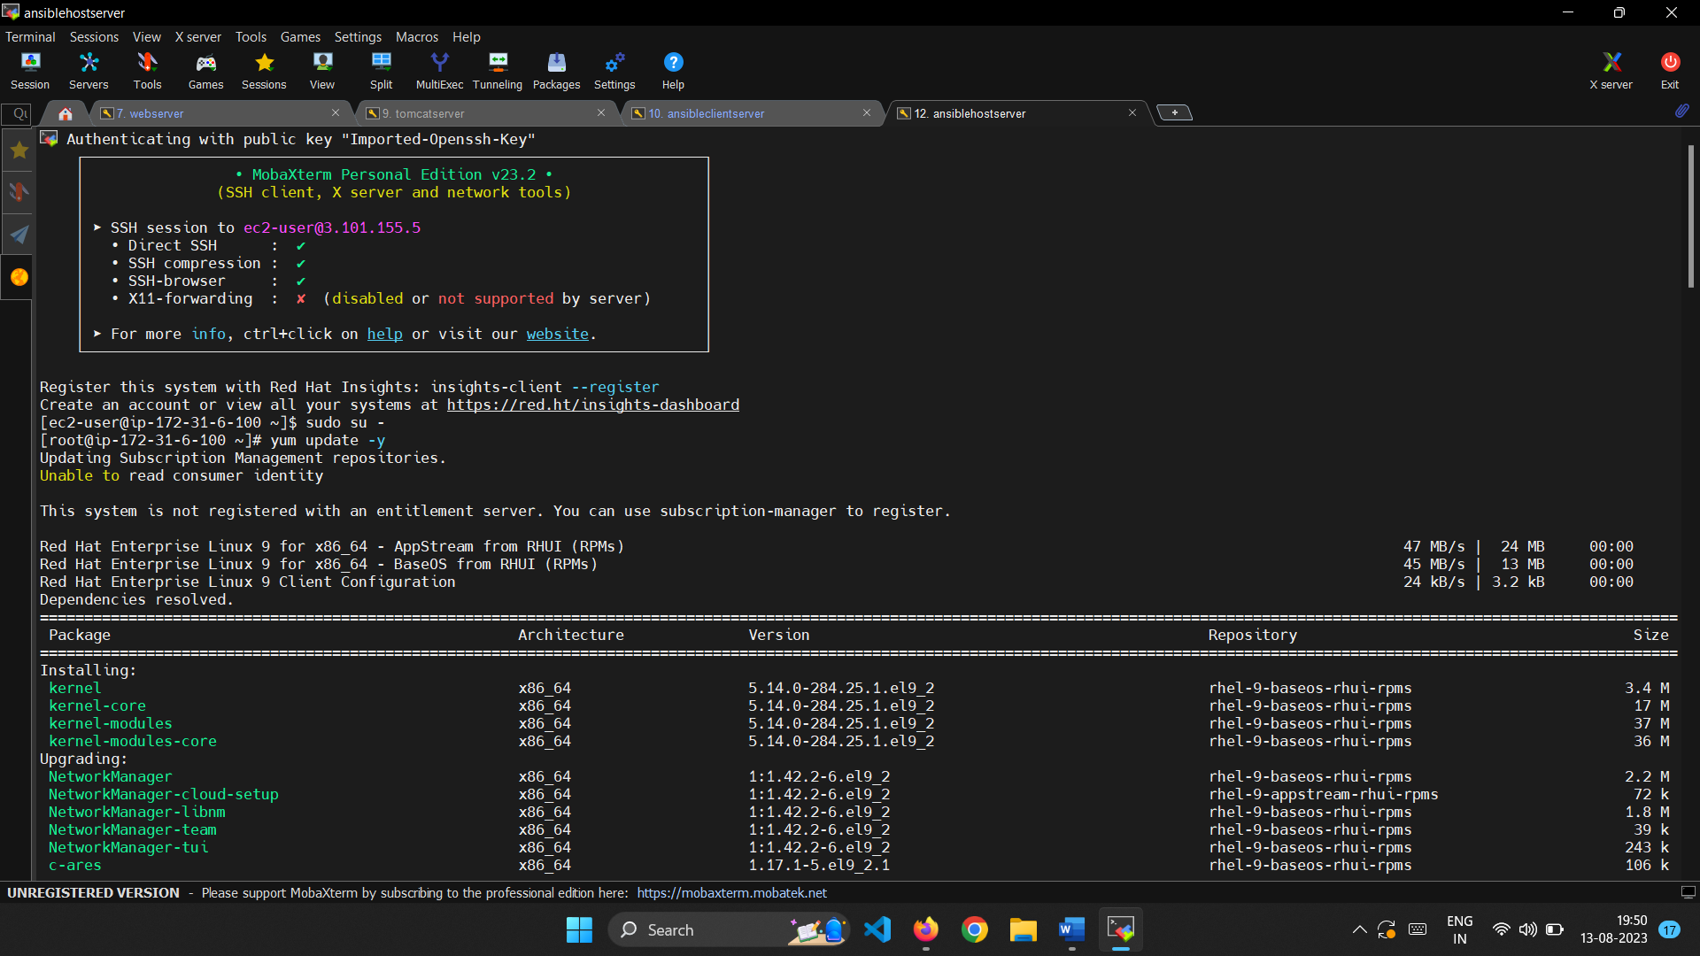

Install the latest epel packages.

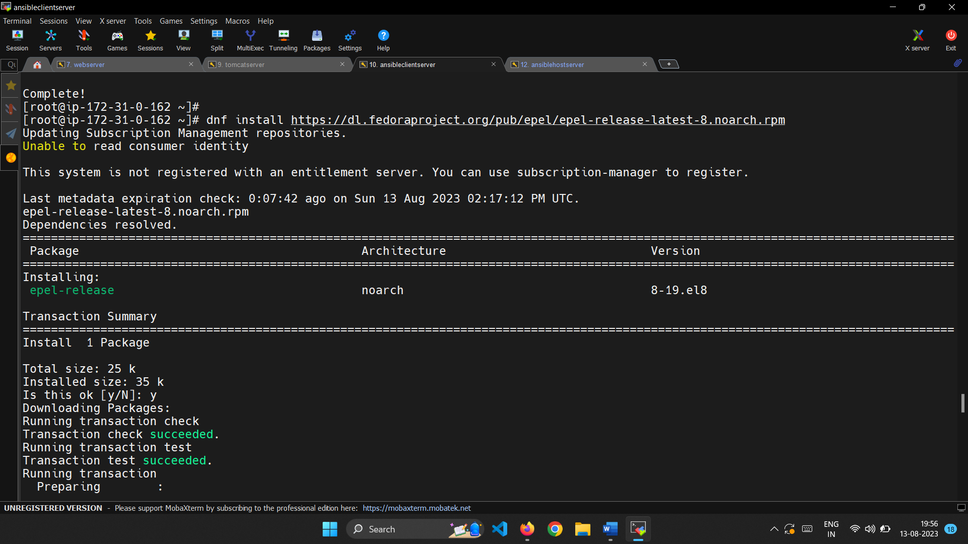

Install ansible in both the servers.

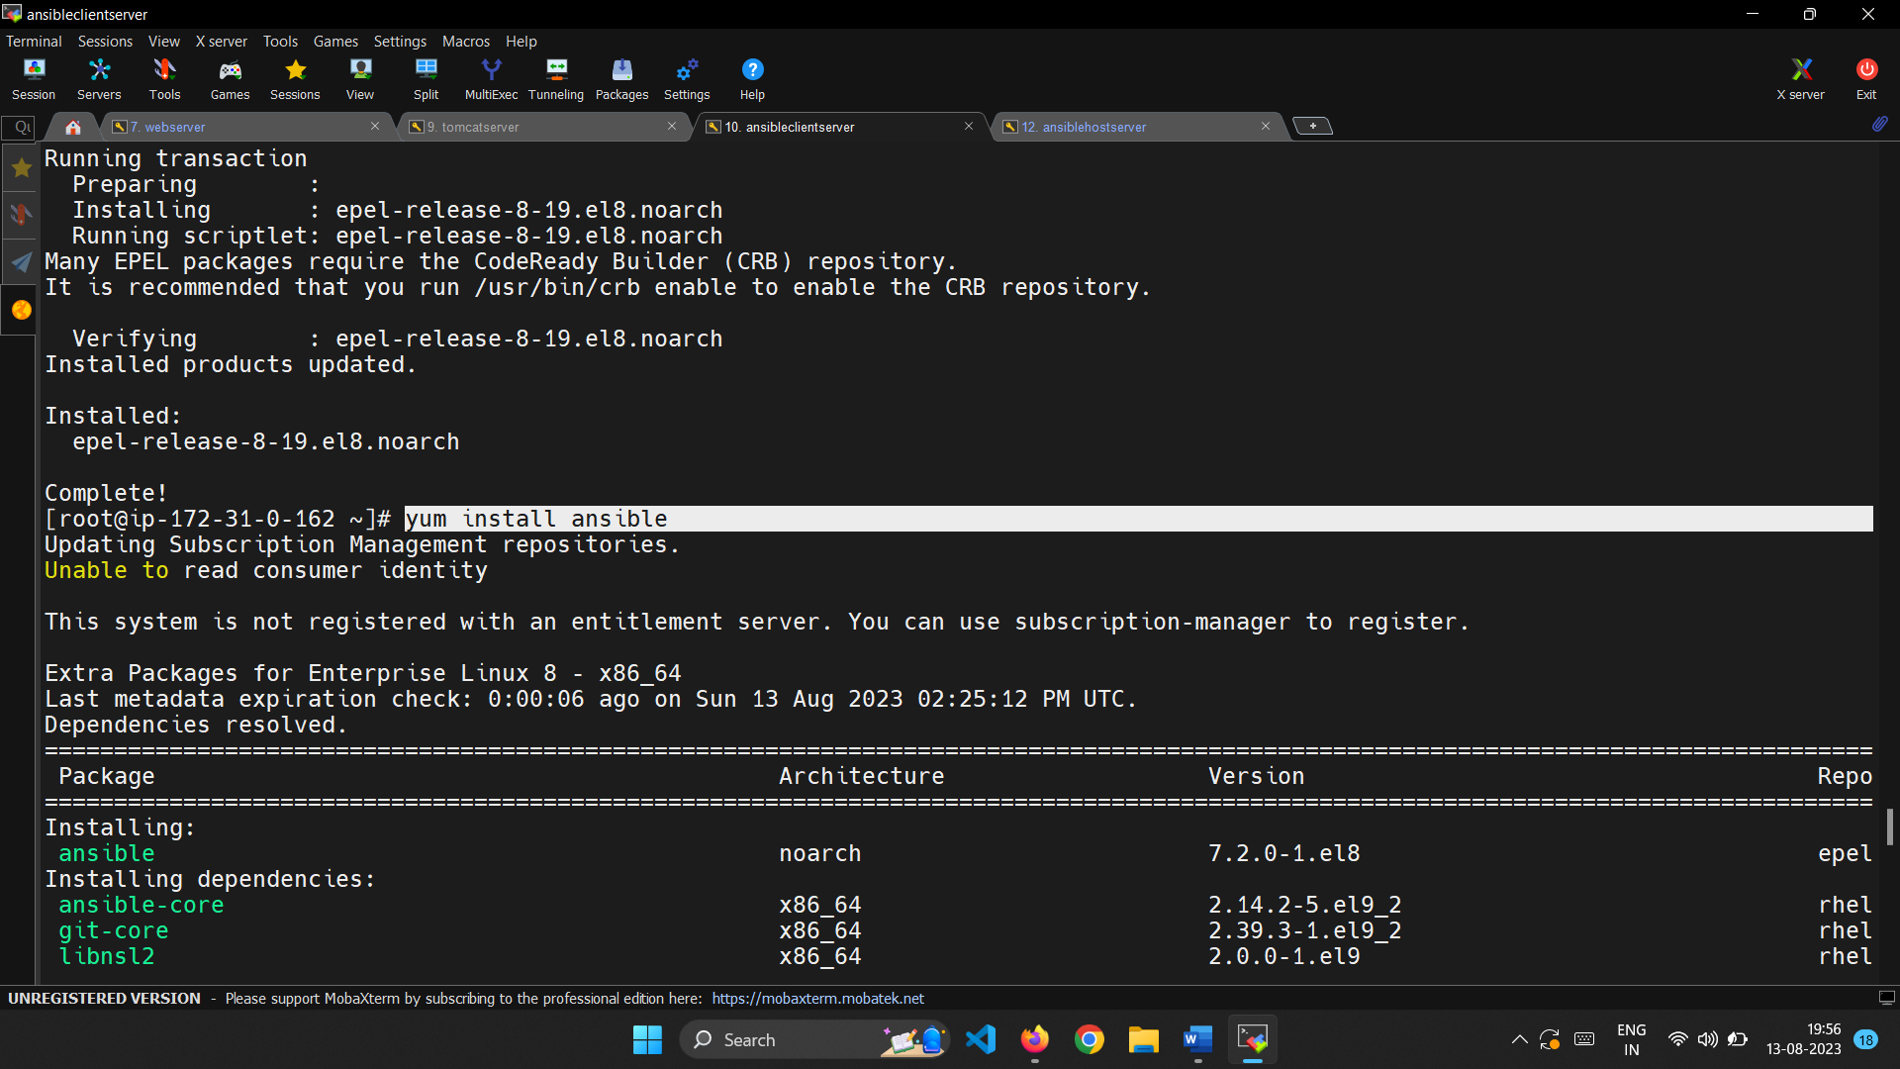

To check whether the ansible is installed or not we can use ansible –version command.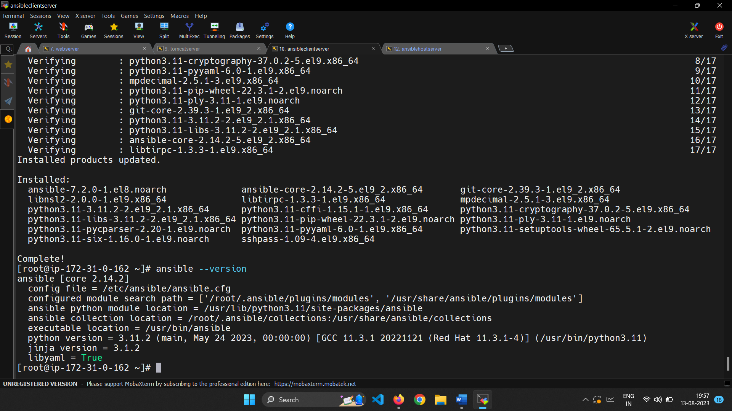

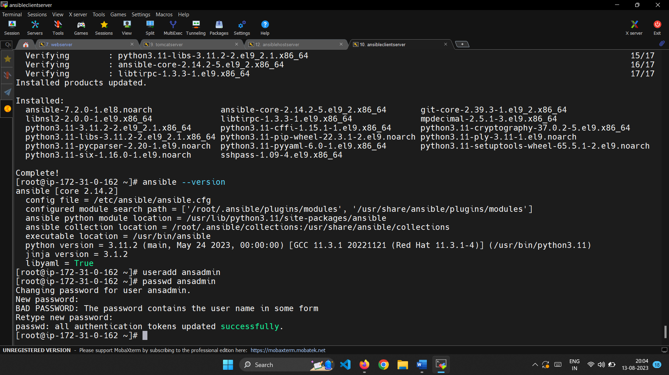

Create a user as ansadmin in host server and client server.

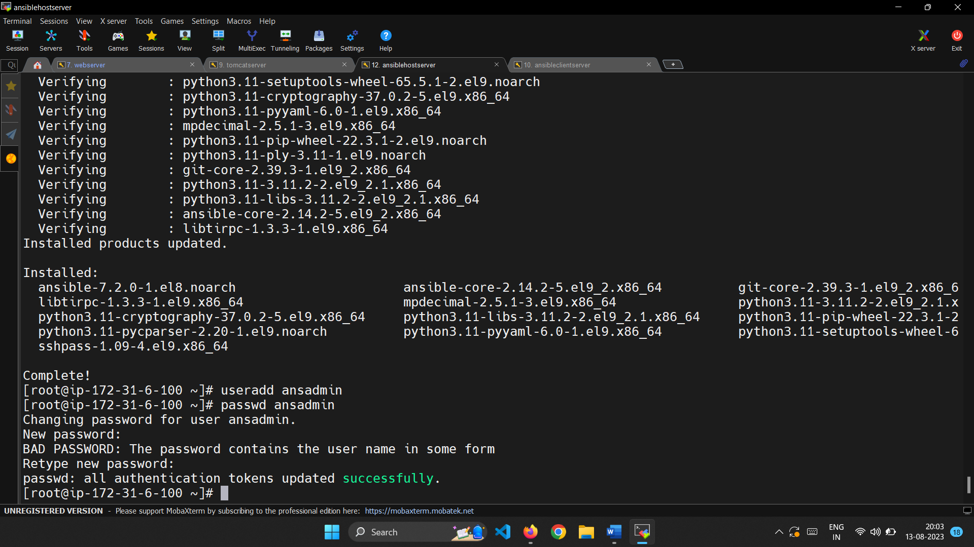

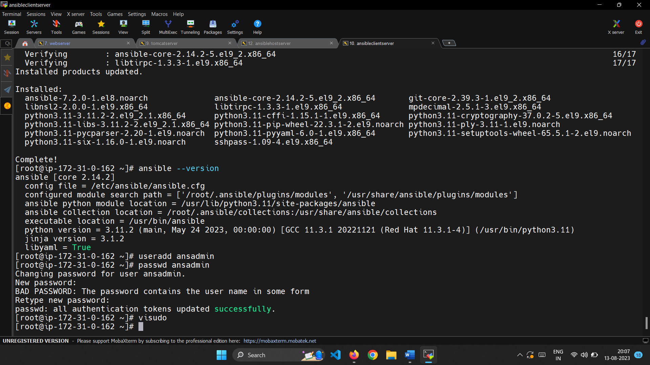

Add the priveleges to the newly created user in visude file.

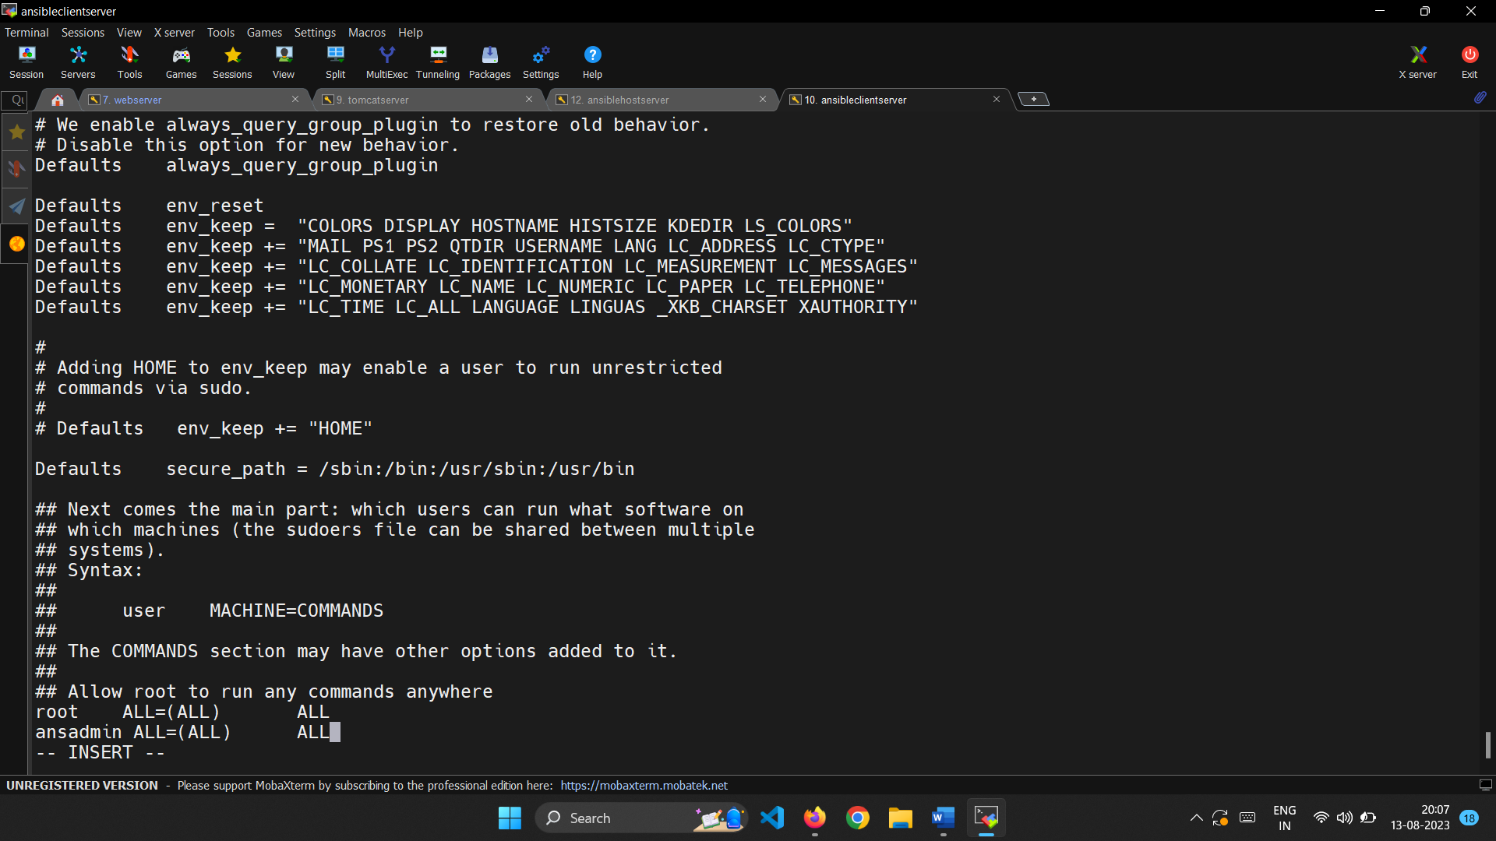

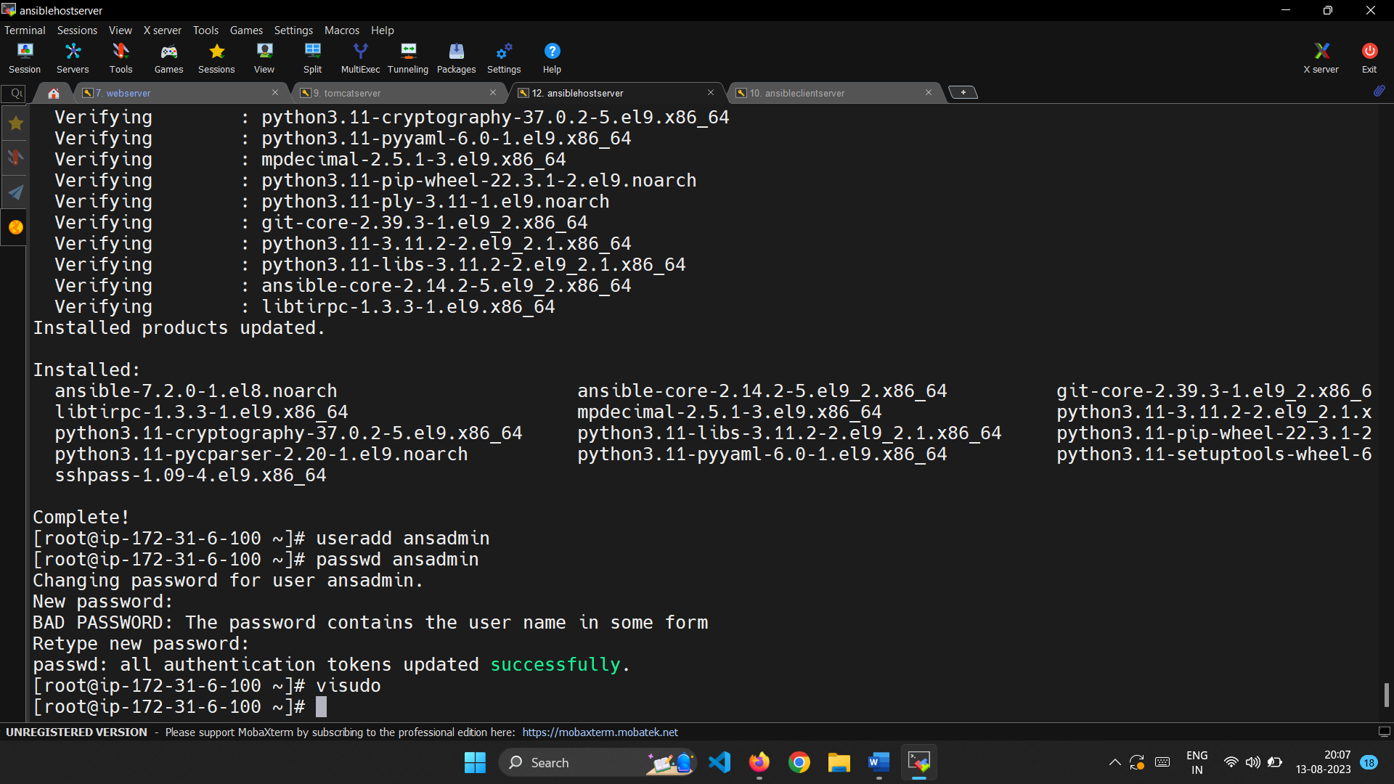



To allow user to login we need to allow the password authentication.

So we need the Password authentication change it in the sshd_config file and restart the service to allow the services to reflect.

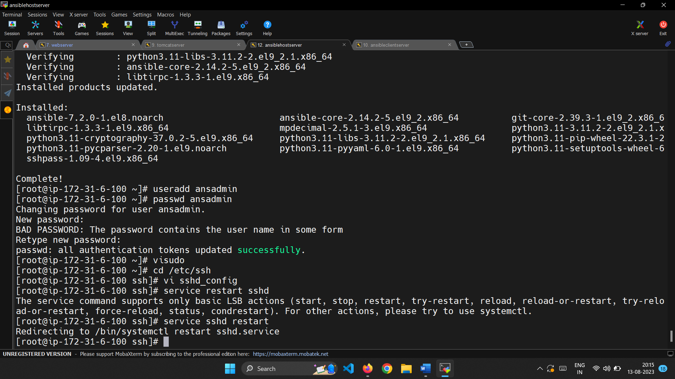

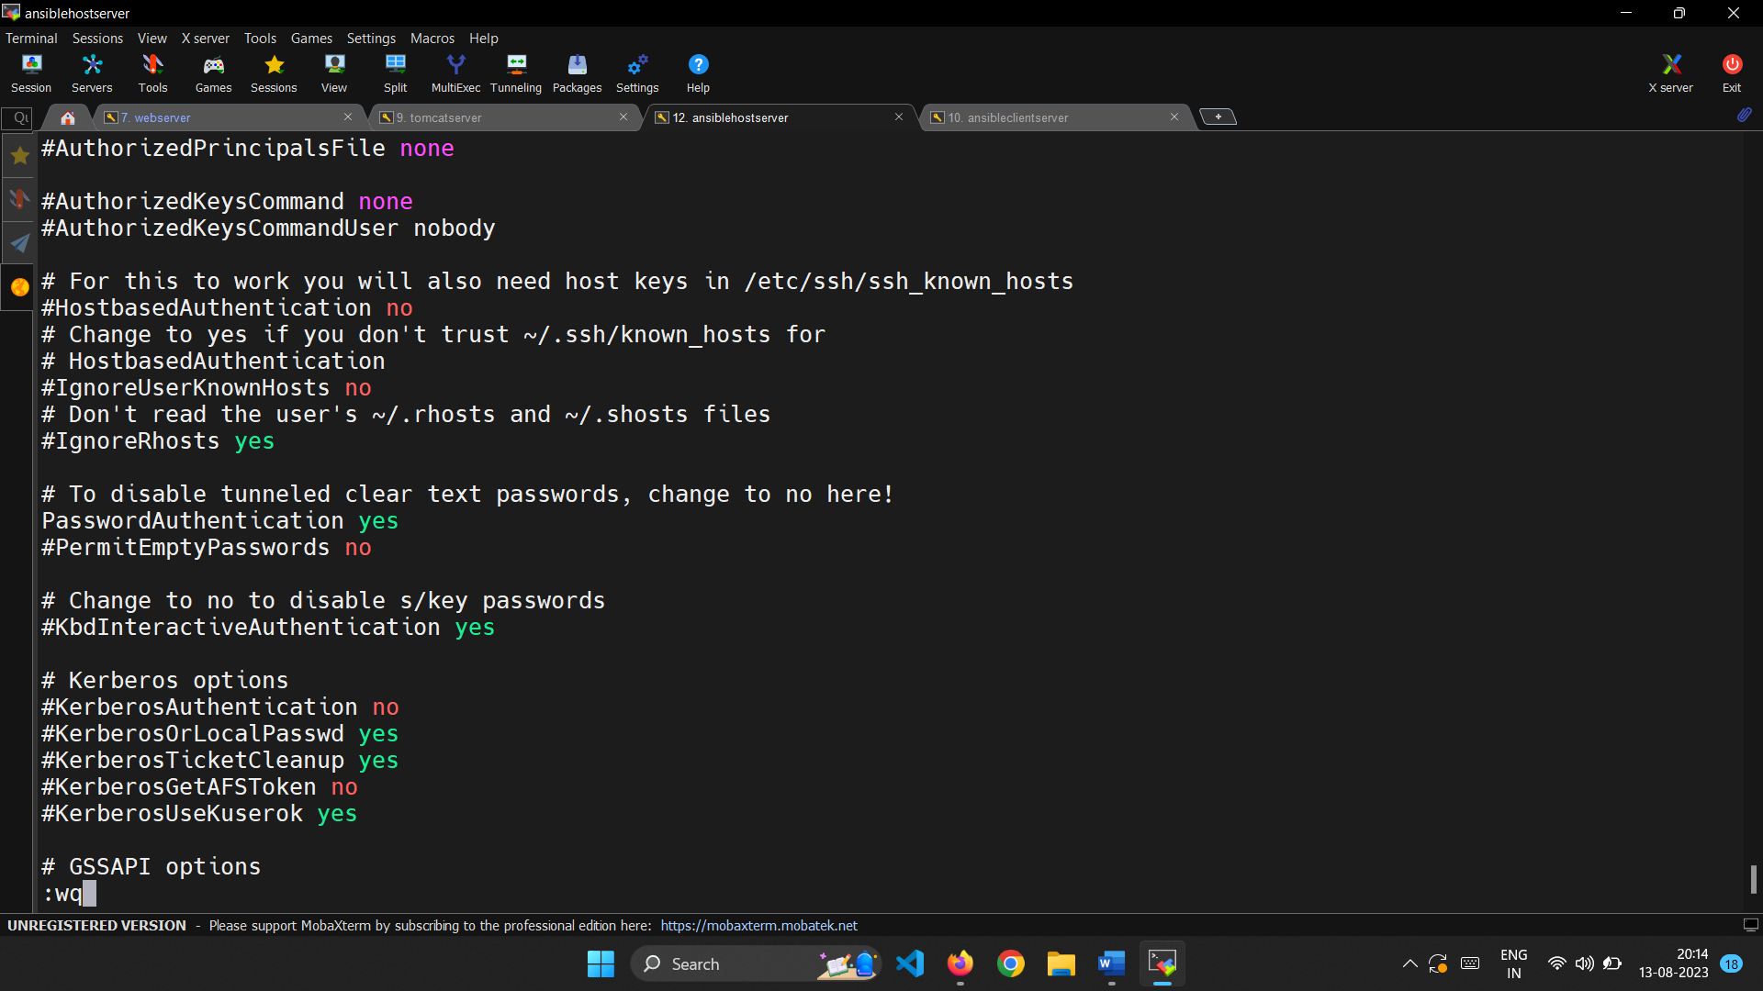

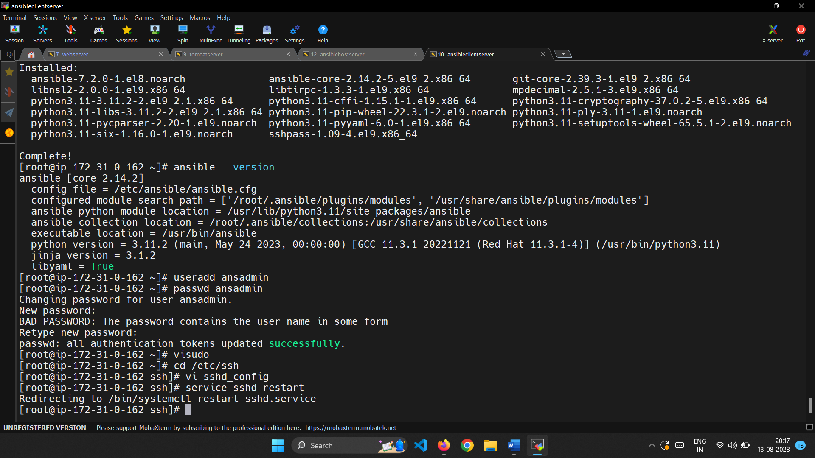

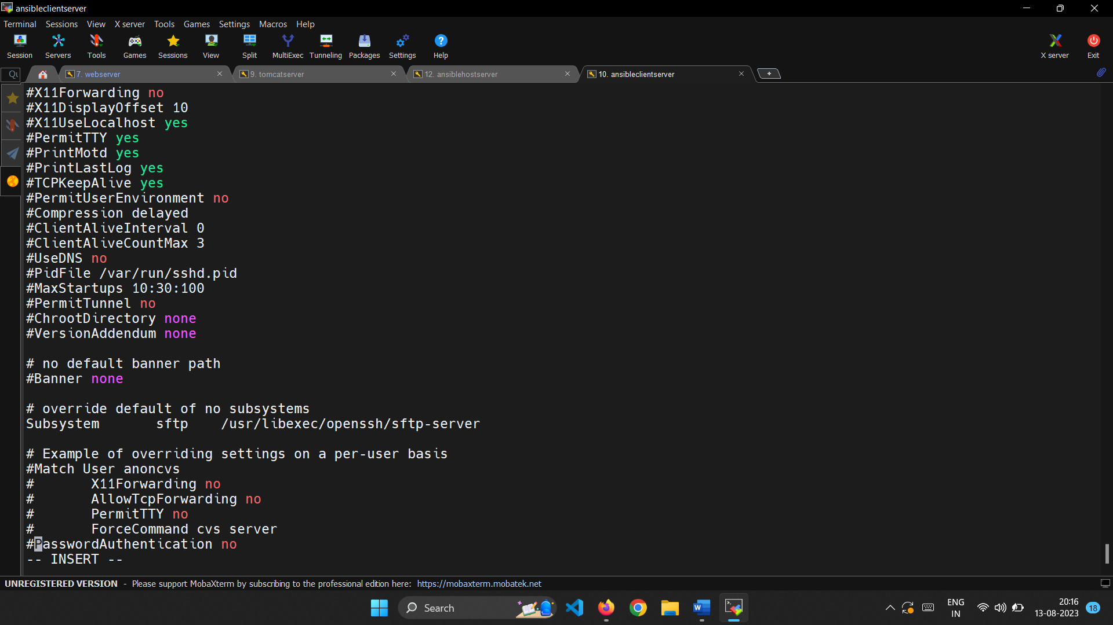

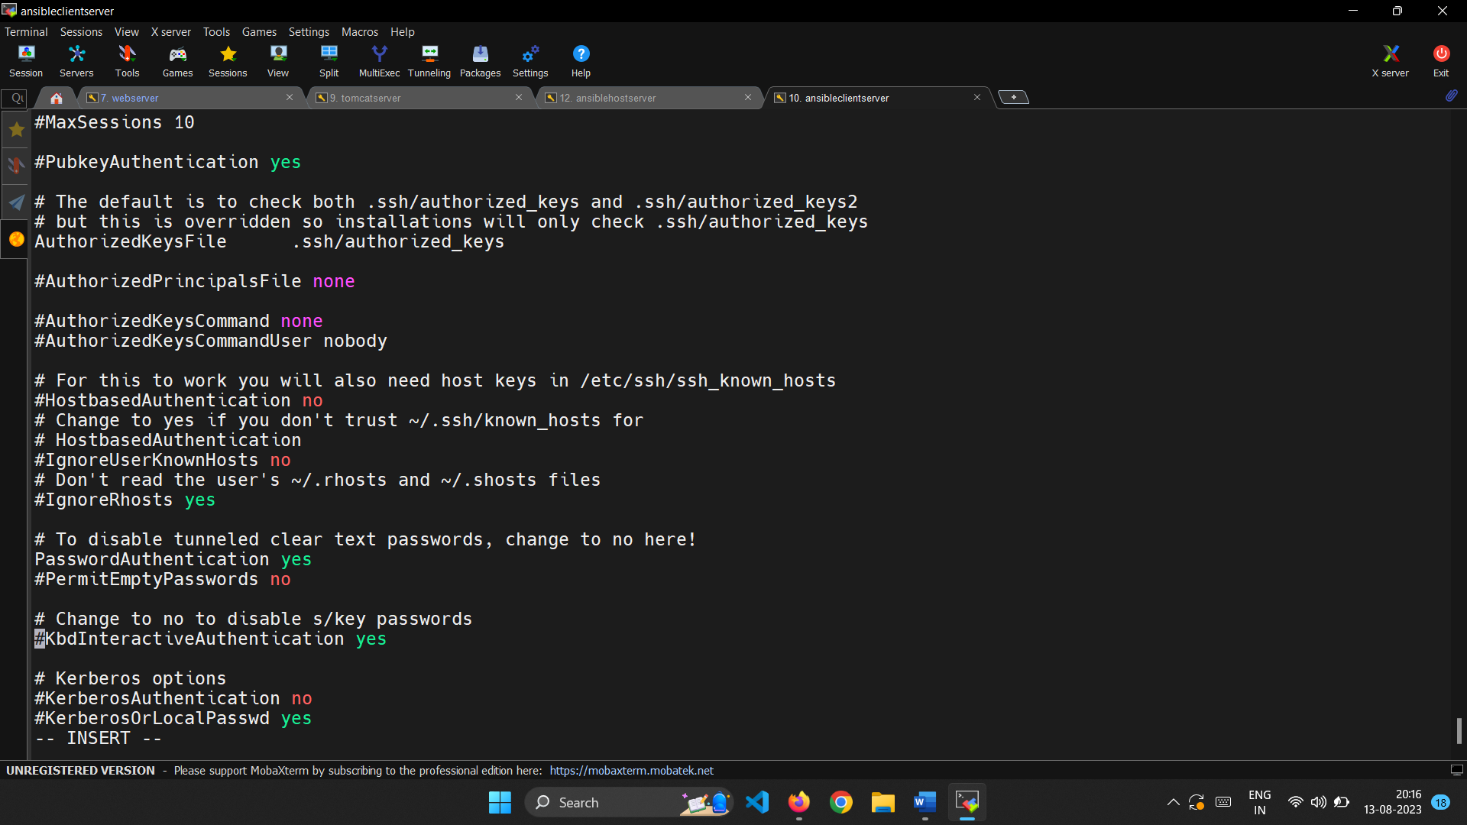

Login in master server as ansadmin.

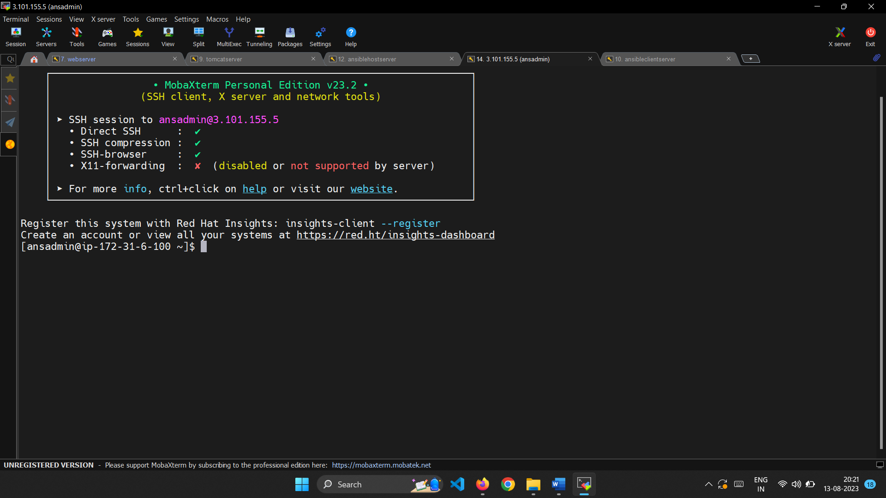

Generate a key pair using ssh-keygen command.

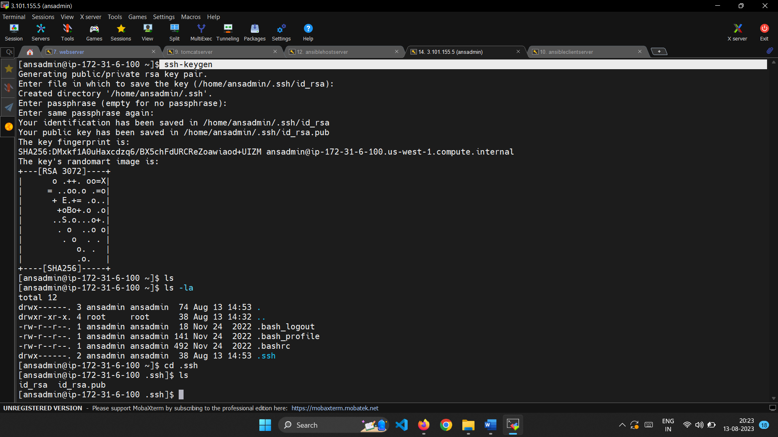

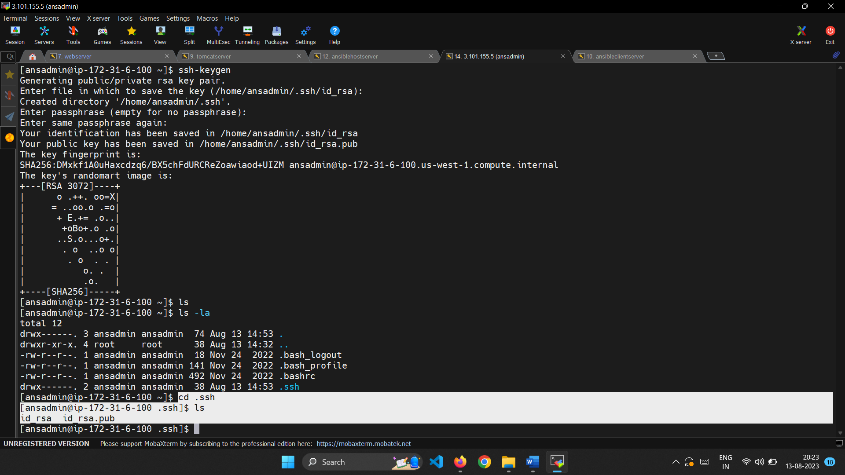

Copy the keypair generated to the cliend server using it’s private IP address.

Now we can login into the client server from the host server.

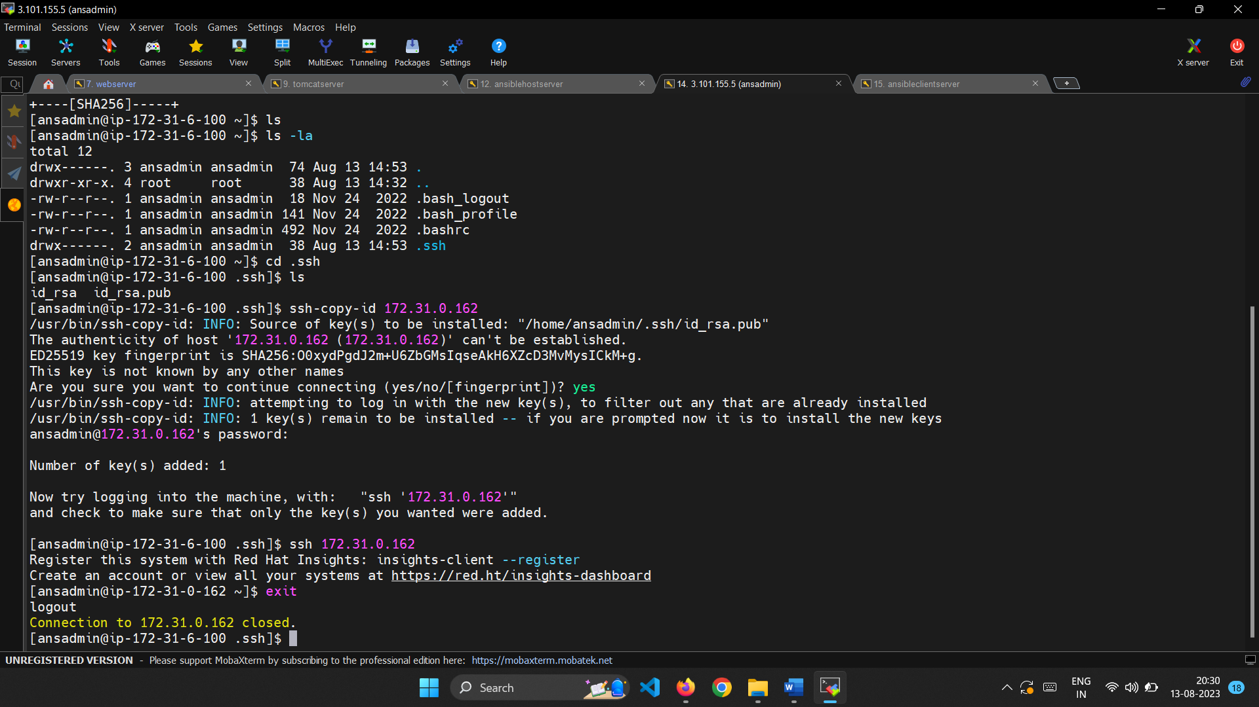

In hosts file add the data as all-hosts and the private IP address of the client server.

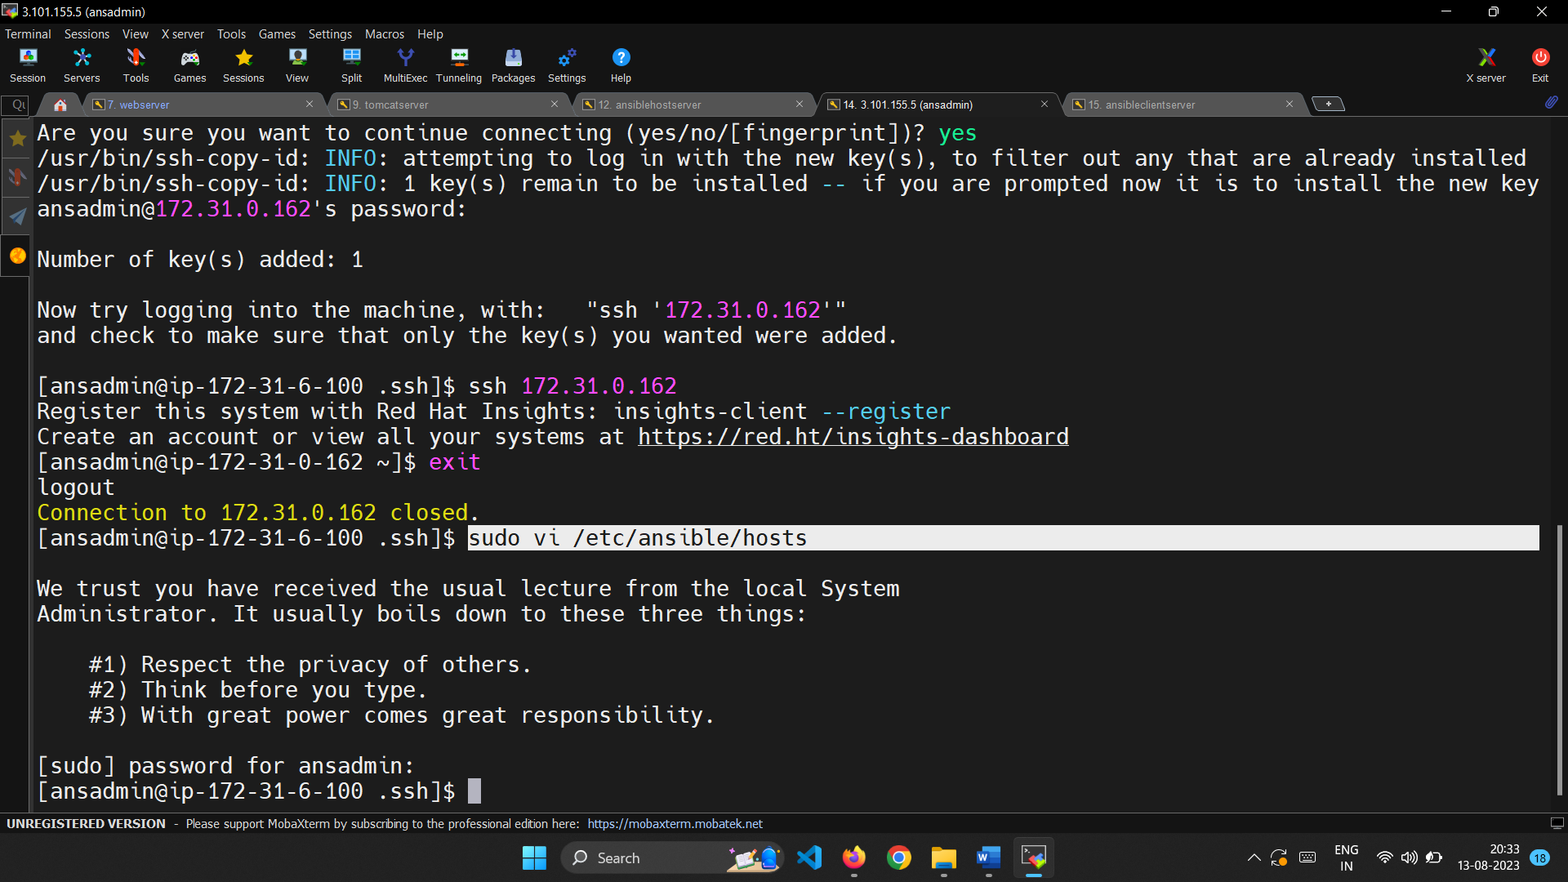

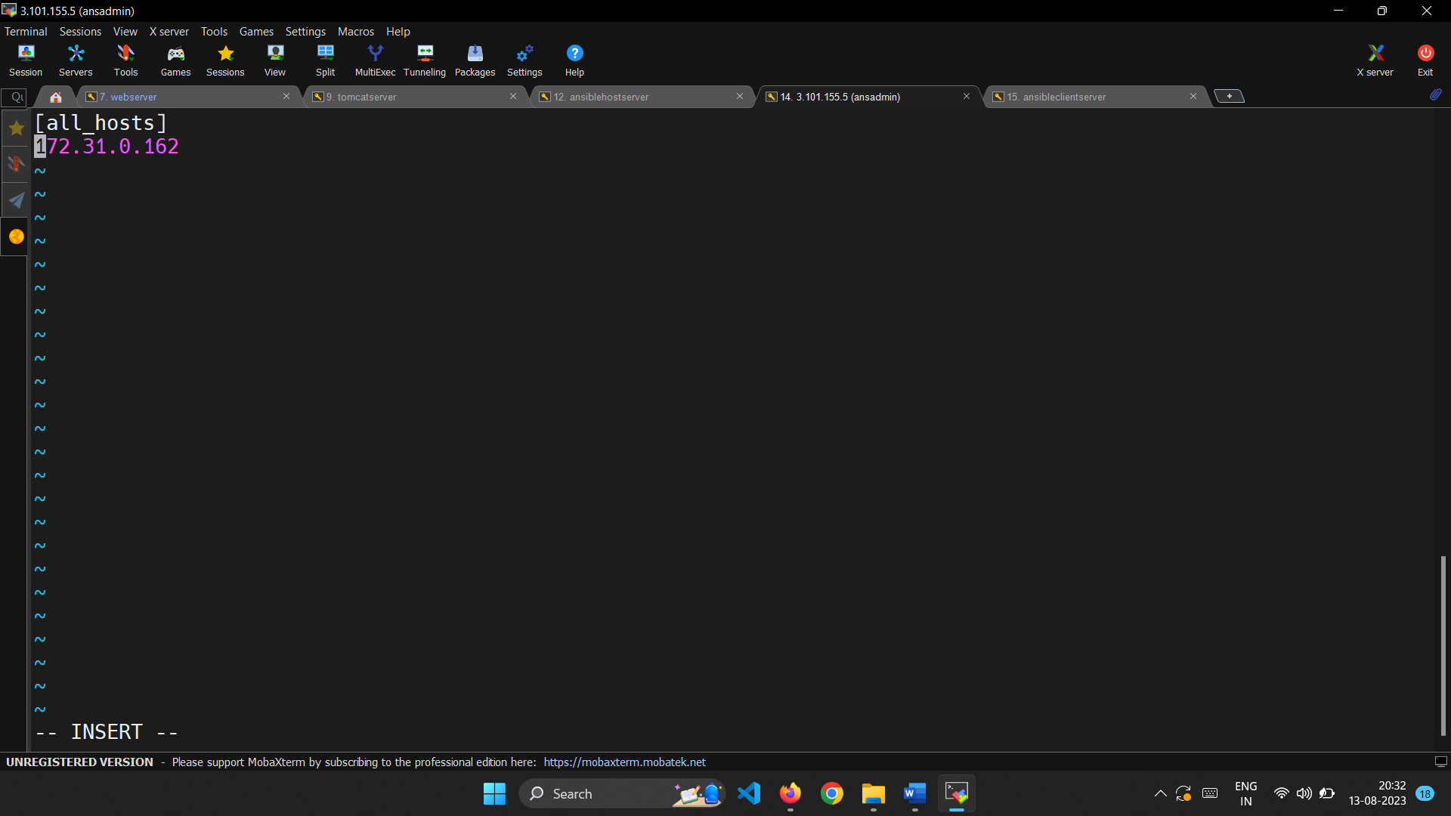

We can test whether the host server can interact with client server by using ping command.

If it returns success then it connection is established.

Let’s test by creating a file in host server.

I have created a hello.html file.

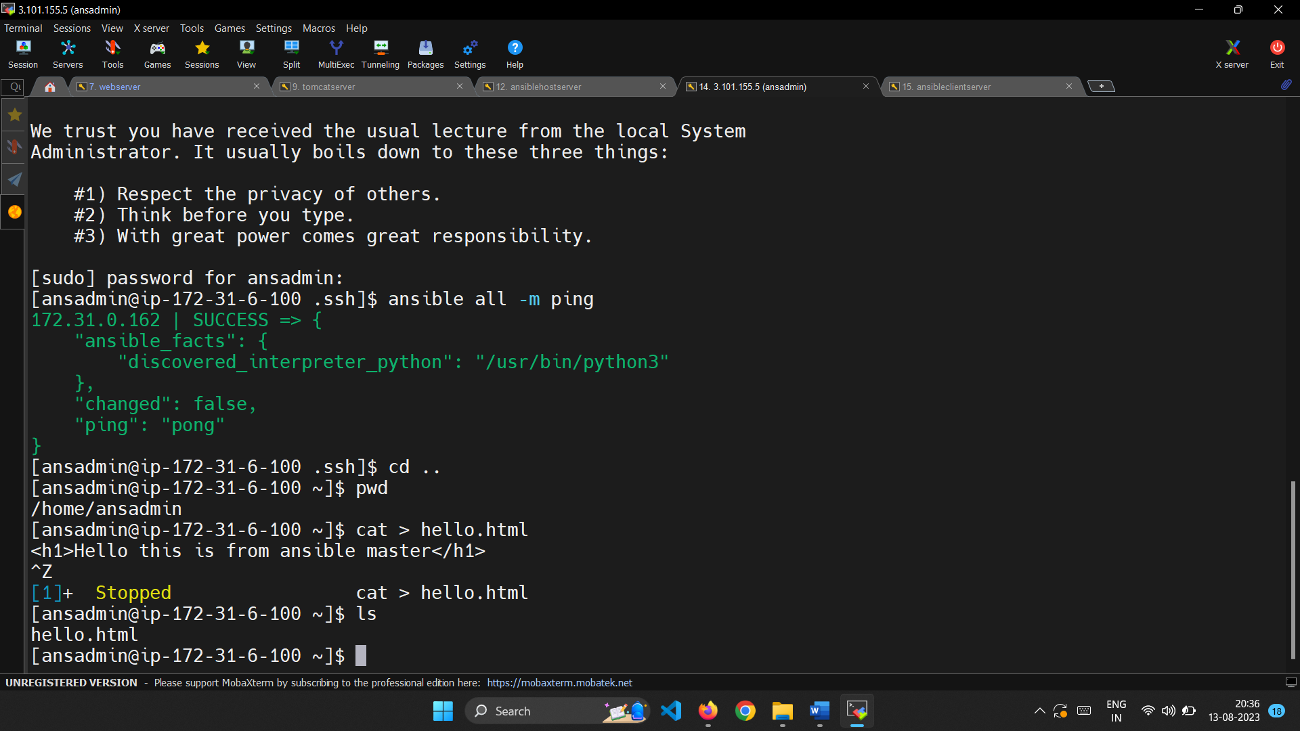

We can use ansible to copy the file from host to client server by specifying the source and destination.

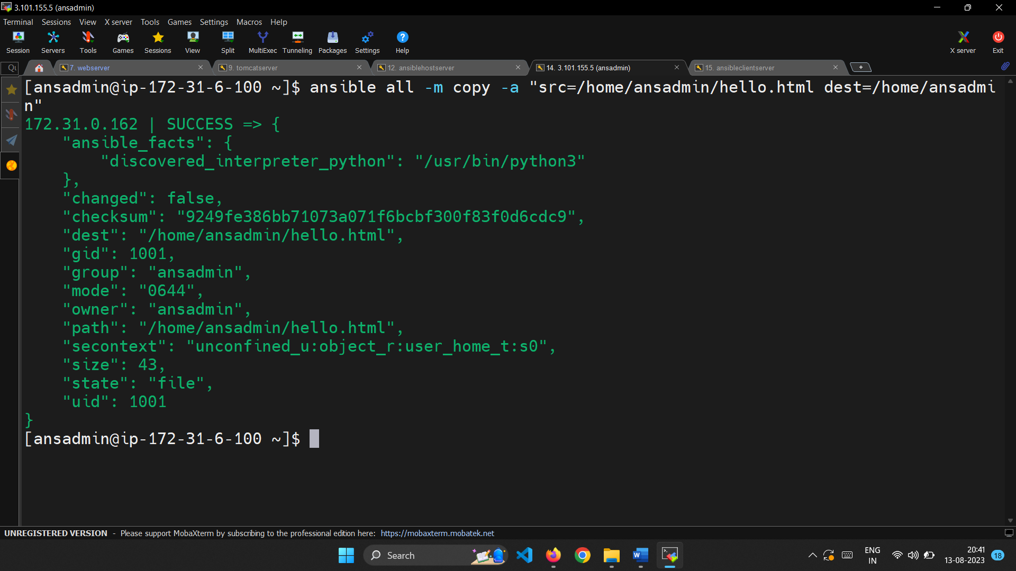

We can view the file in the location where we have specified as destination in client server.

